CAPSTONE PROJECT
AUTOMATED FINANCE DASHBOARD FOR SMALL BUSINESS
PYTHON PROJECT

Code 1
import pandas as pd
import numpy as np
import matplotlib.pyplot as plt
import streamlit as st

Code 2
df=pd.read_csv("Samsung Dataset.csv")

Code 3
df
output

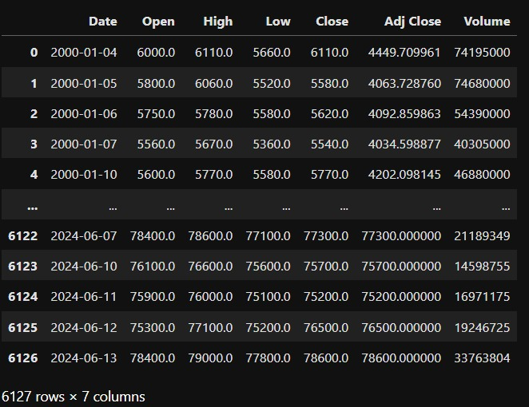

Code 4
df.head()

output
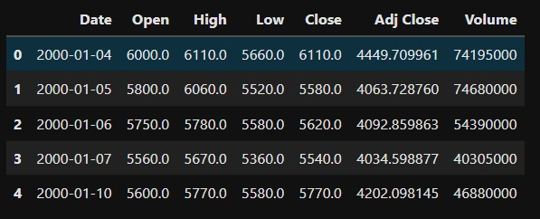

Code 5
df.tail()

output
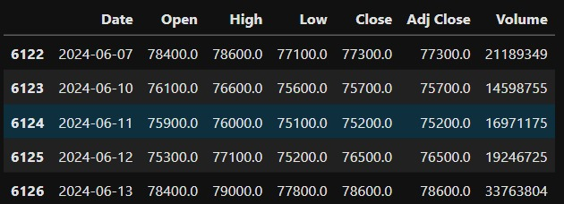

Code 6
df.info()

output
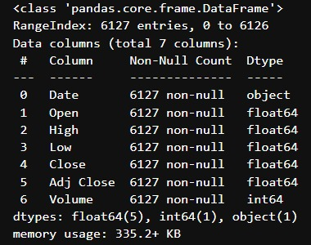

Code 7
df.shape
output
(6127, 7)

Code 8
df.isnull().sum()

output
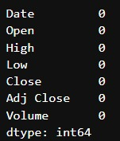

Code 9
df.dtypes

output
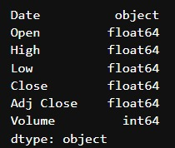

Code 10
df.describe()

Output
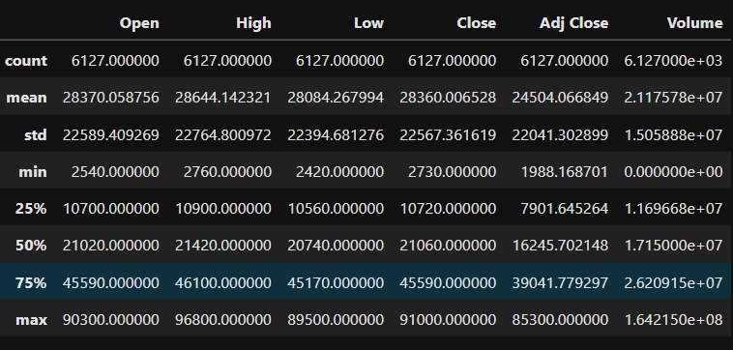

Code 11
df.duplicated().sum()
output
np.int64(0)

Code 12
df["Year"] = df["Date"].dt.year
df["Month"] = df["Date"].dt.month
df["YearMonth"] = df["Date"].dt.to_period("M").astype(str)

Code 13
df["Daily Return (%)"] = df["Close"].pct_change() * 100
Code 14
total_volume = df["Volume"].sum()
print("Total Trading Volume:", total_volume)
output
Total Trading Volume: 129744009493

Code 15
average_close = df["Close"].mean()
print("Average Closing Price:", round(average_close, 2))
output
Average Closing Price: 28360.01

Code 16
highest_close = df["Close"].max()
print("Highest Closing Price:", highest_close)
output
Highest Closing Price: 91000.0

Code 17
lowest_close = df["Close"].min()
print("Lowest Closing Price:", lowest_close)
output
Lowest Closing Price: 2730.0

Code 18
average_volume = df["Volume"].mean()
print("Average Trading Volume:", round(average_volume, 2))
output
Highest Trading Volume: 164215000

Code 20
average_return = df["Daily Return (%)"].mean()
print("Average Daily Return:", round(average_return, 4), "%")
output
Average Daily Return: 0.065 %

Code 21
yearly_summary = df.groupby("Year").agg(
Average_Close=("Close", "mean"),
Highest_Close=("Close", "max"),
Lowest_Close=("Close", "min"),
Total_Volume=("Volume", "sum")
).reset_index()
print(yearly_summary)
output
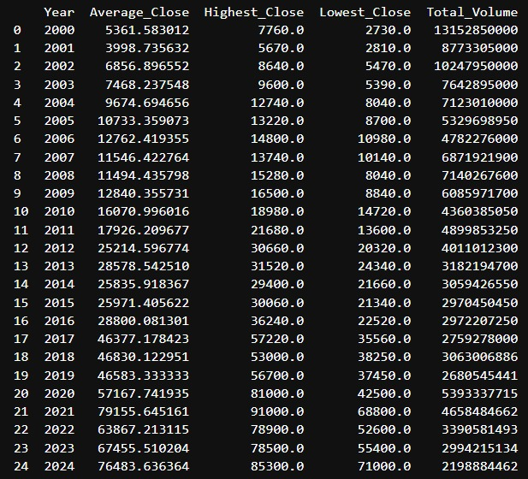

Code 22
monthly_summary = df.groupby("YearMonth").agg(
Average_Close=("Close", "mean"),
Highest_Close=("Close", "max"),
Lowest_Close=("Close", "min"),
Total_Volume=("Volume", "sum")
).reset_index()
print(monthly_summary.head(20))
output
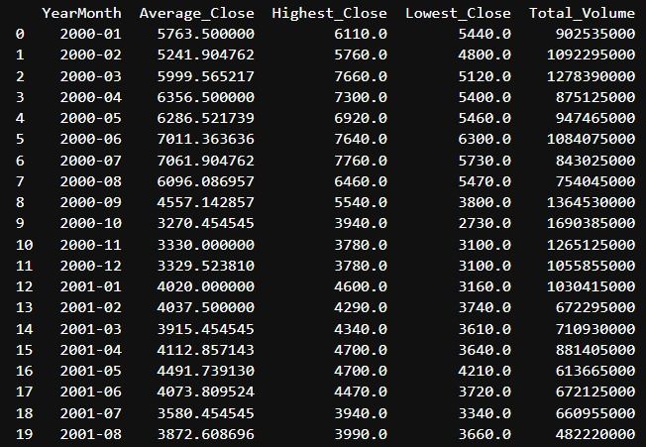

Code 23
month_summary = df.groupby("Month").agg(
Average_Close=("Close", "mean"),
Average_High=("High", "mean"),
Average_Low=("Low", "mean"),
Average_Volume=("Volume", "mean")
).reset_index()
print(month_summary)
output
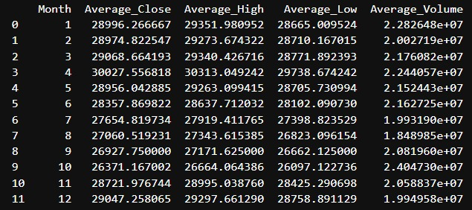

Code 24
plt.figure(figsize=(12, 6))
plt.plot(df["Date"], df["Close"])
plt.title("Samsung Closing Price Trend")
plt.xlabel("Date")
plt.ylabel("Closing Price")
plt.xticks(rotation=45)
plt.tight_layout()
plt.show()
output
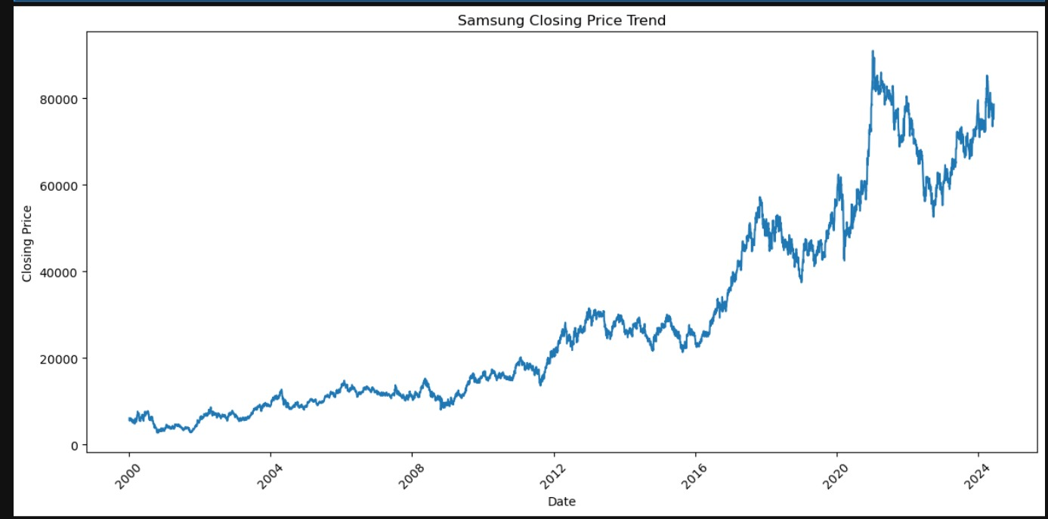

Code 25
plt.figure(figsize=(12, 6))
plt.plot(df["Date"], df["Adj Close"])
plt.title("Samsung Adjusted Closing Price Trend")
plt.xlabel("Date")
plt.ylabel("Adjusted Close")
plt.xticks(rotation=45)
plt.tight_layout()
plt.show()

output
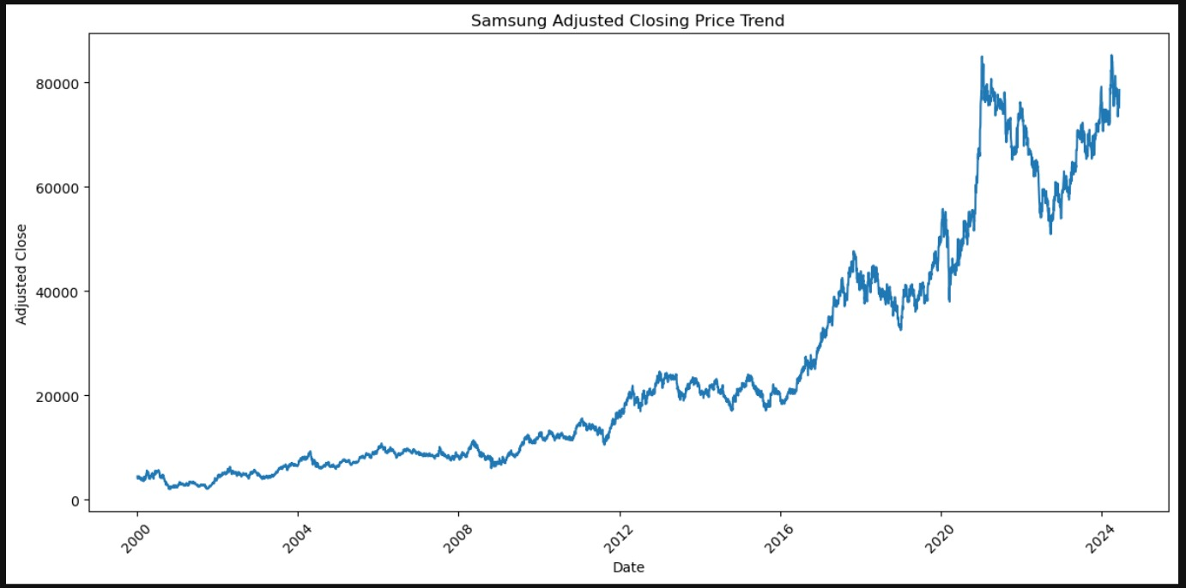

Code 26
plt.figure(figsize=(12, 6))
plt.bar(
yearly_summary["Year"],
yearly_summary["Average_Close"]
)
plt.title("Yearly Average Closing Price")
plt.xlabel("Year")
plt.ylabel("Average Closing Price")
plt.xticks(rotation=45)
plt.tight_layout()
plt.show()

output
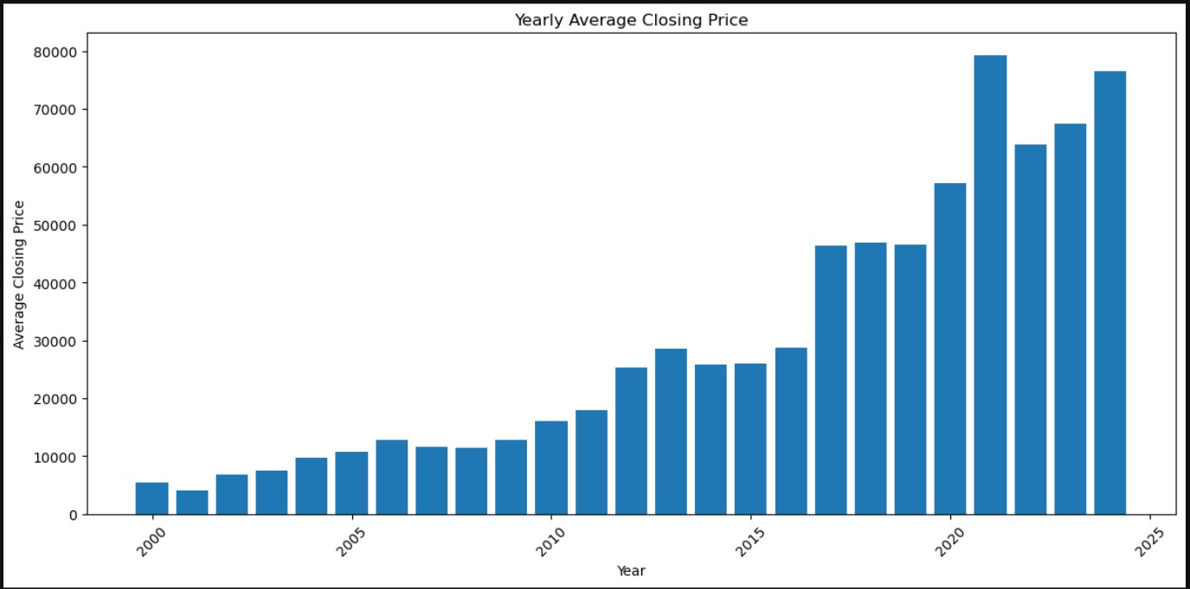

Code 27
plt.figure(figsize=(12, 6))
plt.bar(
yearly_summary["Year"],
yearly_summary["Total_Volume"]
)
plt.title("Yearly Trading Volume")
plt.xlabel("Year")
plt.ylabel("Total Volume")
plt.xticks(rotation=45)
plt.tight_layout()
plt.show()

output
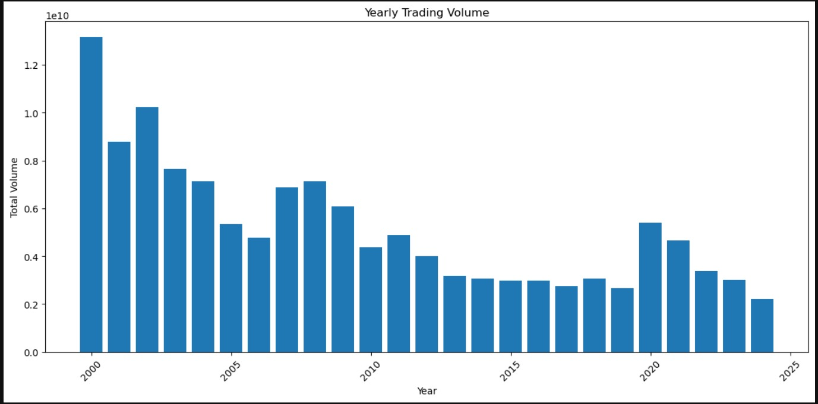

Code 28
plt.figure(figsize=(12, 6))
plt.plot(
yearly_summary["Year"],
yearly_summary["Highest_Close"],
marker="o",
label="Highest Close"
)
plt.plot(
yearly_summary["Year"],
yearly_summary["Lowest_Close"],
marker="o",
label="Lowest Close"
)plt.title("Yearly Highest vs Lowest Closing Price")
plt.xlabel("Year")
plt.ylabel("Price")
plt.legend()
plt.xticks(rotation=45)
plt.tight_layout()
plt.show()

output
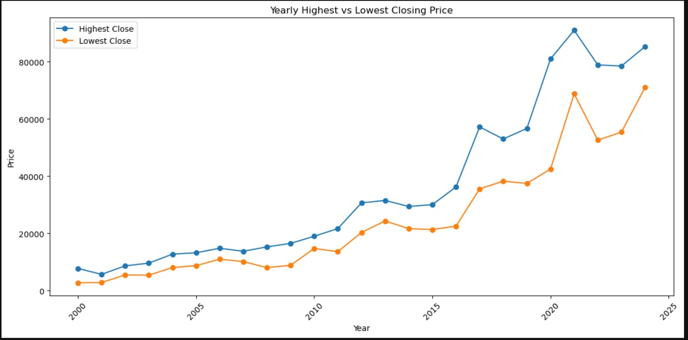

Code 29
plt.figure(figsize=(10, 6))
plt.bar(
month_summary["Month"],
month_summary["Average_Close"]
)
plt.title("Average Closing Price by Month")
plt.xlabel("Month")
plt.ylabel("Average Closing Price")
plt.xticks(range(1, 13))
plt.tight_layout()
plt.show()

output
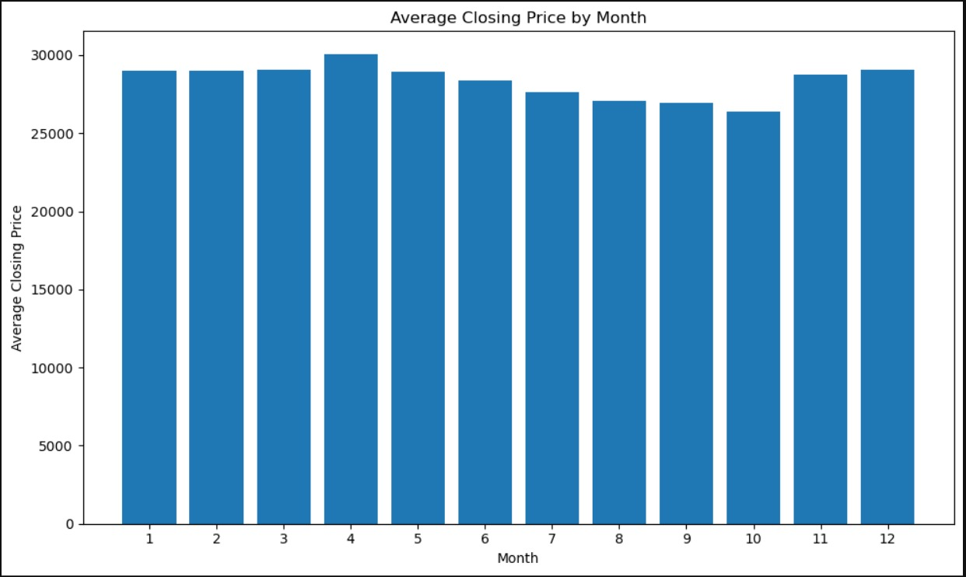

Code 30
plt.figure(figsize=(10, 6))
plt.bar(
month_summary["Month"],
month_summary["Average_Volume"]
)
plt.title("Average Trading Volume by Month")
plt.xlabel("Month")
plt.ylabel("Average Volume")
plt.xticks(range(1, 13))
plt.tight_layout()
plt.show()

output
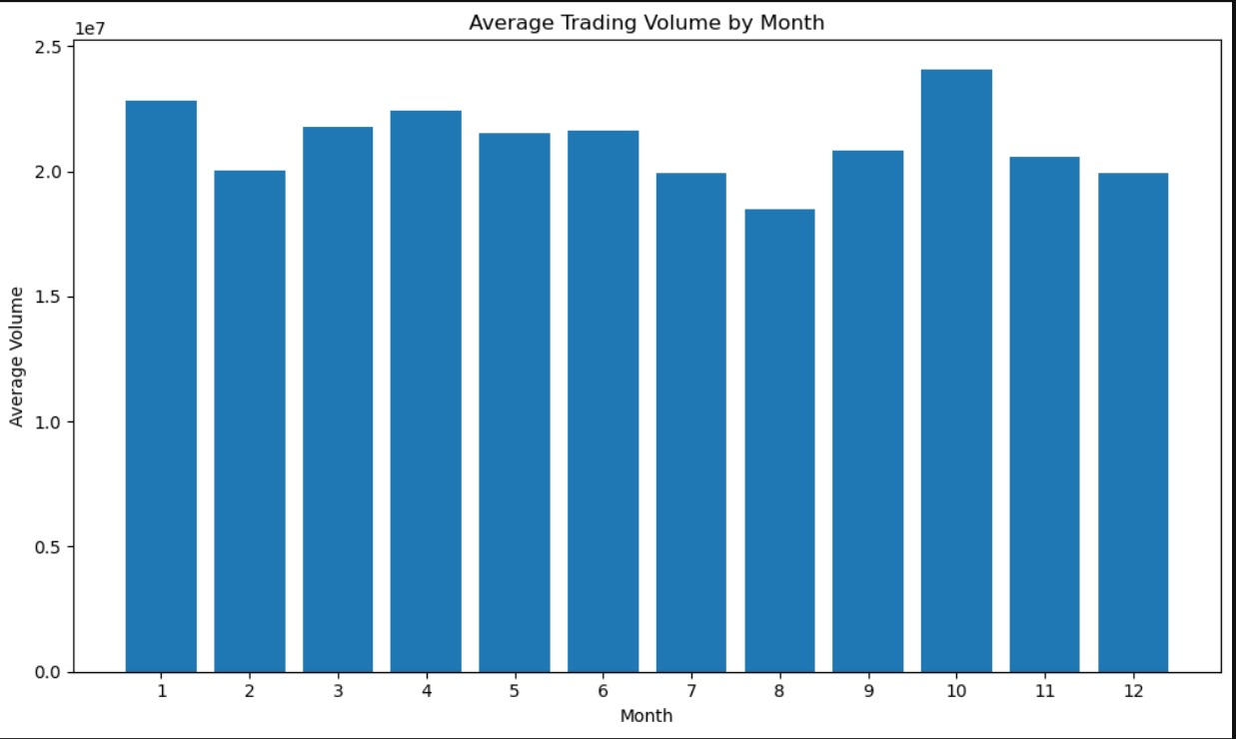

Code 31
plt.figure(figsize=(8, 6))
plt.scatter(
df["Open"],
df["Close"],
alpha=0.5
)
plt.title("Opening Price vs Closing Price")
plt.xlabel("Opening Price")
plt.ylabel("Closing Price")
plt.tight_layout()
plt.show()

output
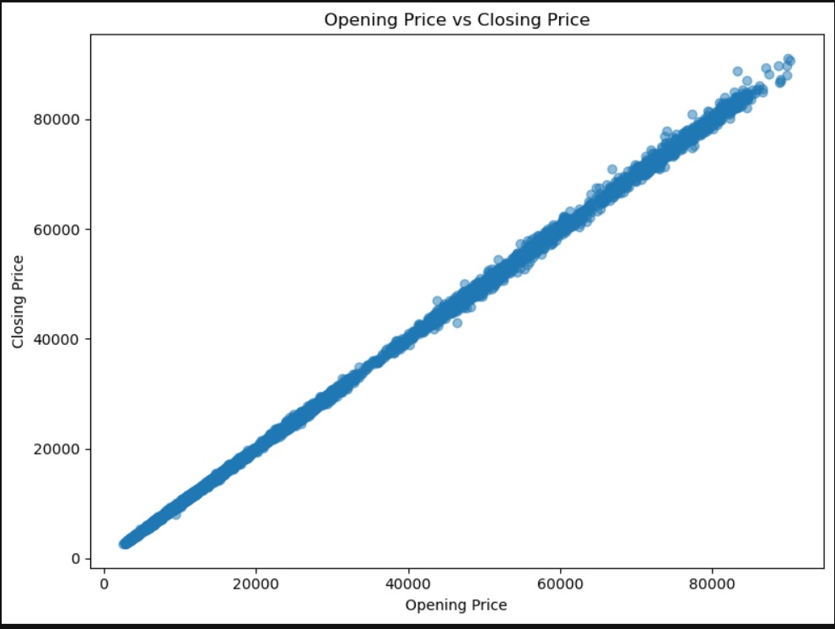

Code 32
print("TOTAL DATA SUMMARY")
print("Total Records:", len(df))
print("Total Columns:", df.shape[1])
print("Start Date:", df["Date"].min().date())
print("End Date:", df["Date"].max().date())
print("Missing Values:", df.isnull().sum().sum())
print("Duplicate Rows:", df.duplicated().sum())
print("\nPRICE SUMMARY")
print("Average Open:", round(df["Open"].mean(), 2))
print("Average High:", round(df["High"].mean(), 2))
print("Average Low:", round(df["Low"].mean(), 2))
print("Average Close:", round(df["Close"].mean(), 2))
print("Average Adjusted Close:", round(df["Adj Close"].mean(), 2))
print("\n--- EXTREME VALUES ---")
print("Highest High:", df["High"].max())
print("Lowest Low:", df["Low"].min())
print("Highest Close:", df["Close"].max())
print("Lowest Close:", df["Close"].min())
print("\nVOLUME SUMMARY")
print("Average Volume:", round(df["Volume"].mean(), 2))
print("Total Volume:", df["Volume"].sum())
print("Highest Volume:", df["Volume"].max())
print("\nRETURN")
print(
"Average Daily Return (%):",
round(df["Close"].pct_change().mean() * 100, 4)
)
print("\nSUMMARY COMPLETE")

output
